Rising T1DE Alliance Brand Identity & Press Kit

BRAND OVERVIEW
The Rising T1DE Alliance (RTA) is a collaborative network dedicated to transforming Type 1 and Type 2 diabetes care through data-driven, patient-centered solutions. Established in 2016 at Children’s Mercy Kansas City with support from The Helmsley Charitable Trust, RTA focuses on proactively identifying and addressing clinical risks using actionable insights. In 2024, Ann & Robert H. Lurie Children’s Hospital of Chicago joined the leadership team to expand the reach of RTA’s innovative methodologies. By fostering collaboration among healthcare institutions, technology developers and researchers, RTA is driving the development of scalable solutions that close care gaps, enhance patient outcomes and shape the future of diabetes management.

VISUAL IDENTITY

Logo Usage
- The official RTA logo should always be used in its original form, maintaining its blue and white color scheme for clarity and brand consistency.
- Boat and origami: We harness data overlooked by much of the healthcare ecosystem, combining Al and human expertise to illuminate systemic insight across the entire care journey.
- Symbolic boat represents hope.
- The origami shape represents the precision of care.
- “Set sail” is the phrase that embodies the message of the origami boat.
- The logo should not be modified, stretched, recolored, or altered in any way.
- Adequate padding should be maintained around the logo to keep it visually clean and distinct.
- Partner organization logos (e.g., Children’s Mercy Kansas City, Ann & Robert H. Lurie Children’s Hospital of Chicago) should not be included alongside RTA branding without explicit approval.

Logo Applications
The RTA logo is a key visual element of our brand identity and should be used consistently across all materials to maintain recognition and integrity. Approved usage includes, but is not limited to:
- Digital Media
  - Website headers, social media graphics, email newsletters, digital ads and online presentations.
- Print Materials
  - Flyers, brochures, one-pagers, signage, posters and event materials.
- Partnership Acknowledgement
  - May be used by partners or affiliates with written permission, in accordance with the RTA brand guidelines.
- Presentations and Reports
  - Slide decks, grant reports, academic or institutional publications referencing CTIP or RTA-affiliated work.

Logos & Iconography
Please download the RTA logo from the official logo kit on our website.
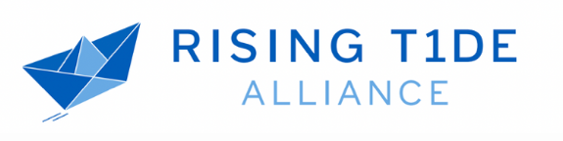

Color Palette
  Dark Blue  - CMYK: 100, 56, 0, 3  - HEX: #005CB9 |   Light Blue  - CMYK: 54, 19, 0, 0  - HEX: #6DABE4

These colors should be used consistently across digital/print materials to maintain brand recognition.

Typography
RTA’s typography reflects clarity and modernity:
- Montserrat is the official font for all branding materials. Roboto is the official font for subheadings and body copy.
- Headers should be bold and easy to read, ensuring a strong visual presence.
- Subheadings and body text should maintain a clean and professional appearance, ensuring readability across various platforms.

